HAV
Student’s Name
Intuition
Lecturer
Date

Introduction
Hepatitis A virus (HAV) is a non-enveloped hepatotropic virus classified in the Hepatovirus genus in the family of Picornaviridae. HAV has been known for causing a liver infection that is rarely fatal. HAV infection is more frequently seen in developing countries, especially in children as HAV is transmitted through contaminated food and drink [4]. According to the World Health Organization, appropriately, 1.4 million people acquire Hepatitis A virus annually [6]. Hepatitis A does not cause long term illnesses like Hepatitis B and C; hence infected people can recover fully [6]. HAV symptoms can last up to two months; however, the best way to prevent HAV infection is by vaccination. I have always been interested in learning the hepatitis virus in all its types A, B, C, D, and E. I found this to be a great opportunity to learn more about HAV.
The picture blow shows HAV


Transmission
Hepatitis A virus gets transmitted from one person to another through the faecal-oral process when a person ingests food or water contaminated by faeces. Human waste of a person infected by hepatitis A virus forms the main breeding of the hepatitis A virus. When a person does not wash his or her hands properly at the time of preparing food, it can lead to the transmission of the hepatitis A virus [6]. The hepatitis virus exists within the contaminated materials within the environment. For example, handling sewage contaminants and eating fruits can lead to hepatitis A virus infection. Proper handwashing is the main method of prevention of HAV transmission. Close physical contact with contaminated surfaces or infected people can lead to the spread of HAV. Activities such as anal and oral sex can lead to the spread of the hepatitis A virus.
Prevention and Vaccination
Vaccination needs to be considered a comprehensive plan for preventing and controlling hepatitis A form getting viral. Planning for robust immunization programs needs to involve careful economic evaluations and use additional prevention methods. The methods of avoiding the hepatitis A virus include improved sanitation and hygiene practices. The process of conducting child immunizations must get developed to reduce the future occurrence of the hepatitis A virus [5]. Children in different countries have the opportunity to access universal immunization benefits—the majority of people getting exposed to getting hepatitis A virus infection because of the poor state of the environment. For instance, people living in dilapidated areas get exposed to contracting hepatitis A virus infection.
Most countries have developed hepatitis A immunization schedules that are significant in health outcomes. Most countries use two dose regimens as inactivated hepatitis A vaccine. The use of the vaccine got recommended for people who were at risk of hepatitis A. The people include the users of recreational drugs and travellers to countries where the virus is endemic. The recommendation of vaccination for hepatitis A virus needs to become site-specific. The creation of the feasibility of implementing widespread immunization campaigns must get included in the plan. Everybody would know about understanding the need for creating hygiene. Vaccination is important in controlling the widespread outbreak of hepatitis A virus in countries [5]. Creation of campaigns would champion for increasing immunization processes within states. All the age groups in countries would have the opportunity of accessing productive health care. Vaccinations efforts can get supplemented by health education in different parts of the world. The training would help in increasing the need for improved sanitation, hygiene practices, and food safety. People would get urged to practice hygiene when handling matters concerning food processes at any level.
Prevention of hepatitis A can get done through maintaining good personal hygiene and sanitation. Washing hands using soap needs to get done after visiting the toilet, changing diapers, and preparing food. Washing fruits and vegetables before arriving prepared is effective in preventing hepatitis A from affecting people. The improvement of cleanliness within the environment forms a significant basis for preventing hepatitis A virus transmission [3].
Most people suffer from hepatitis A virus because they lack the discipline of maintaining proper hygiene. Besides, getting vaccinated against HAV is another way of keeping from the virus. Most parts of the US approve the use of Hepatitis A virus for people older than 12 months and above. The vaccine is safe for pregnant people, breastfeeding women, and HIV positive people. Within six months, two shots of Hepatitis A virus get administered to people. HIV infected people with low CD4 counts need to get a higher dose of two shots of the vaccine. To get fully protected, everybody must understand the two shots of HAV vaccination. The people living with HIV must get vaccinated when they travel to areas with high Hepatitis A. Lastly, an injection of immune globulin can help prevent HAV infection to people who never got vaccinated. Post-exposure prophylaxis provides short term protection against disease that may get developed by Hepatitis A virus. Immune globulin can get administered to people after two weeks of exposure to the Hepatitis A virus. The vaccine is crucial in preventing the occurrence of hepatitis A in the lives of people. People above 40 years can use either immune globulin or hepatitis A vaccine after getting exposed to the virus.
THE STRUCTURE OF HAV

Diagnosis and Treatment
Doctors typically perform blood tests for antibodies to ensure anybody infected with hepatitis A gets diagnosed. The incubation period for HAV ranges from 15 to 50 days [2]. The infected people can spread the virus to others within this period hence the need for diagnosis. The incubation period gets shorter as people become older. Carrying out blood tests on antibodies allow HAV to get diagnosed in the body of infected people [1]. There are signs of hepatitis A that gets recorded during testing. They include loss of appetite, vomiting, fatigue, nausea, dark-coloured urine, and fever. Some people do not show symptoms at all, with only flu getting observed. No treatment of hepatitis A virus does exist, but rest and proper nutrition can reduce its symptoms. Supportive care and tests help make the immune system of patients reduce the increase of hepatitis A infection. People can take two months to recover, but some can take up to six months. The infected patients must stay away from alcohol and medications that may affect the liver. The use of alcohol tends to affect the liver's performance, hence leading to severe problems within the body. Hepatitis A virus affects the mass of people using alcohol while in their sickness mode.
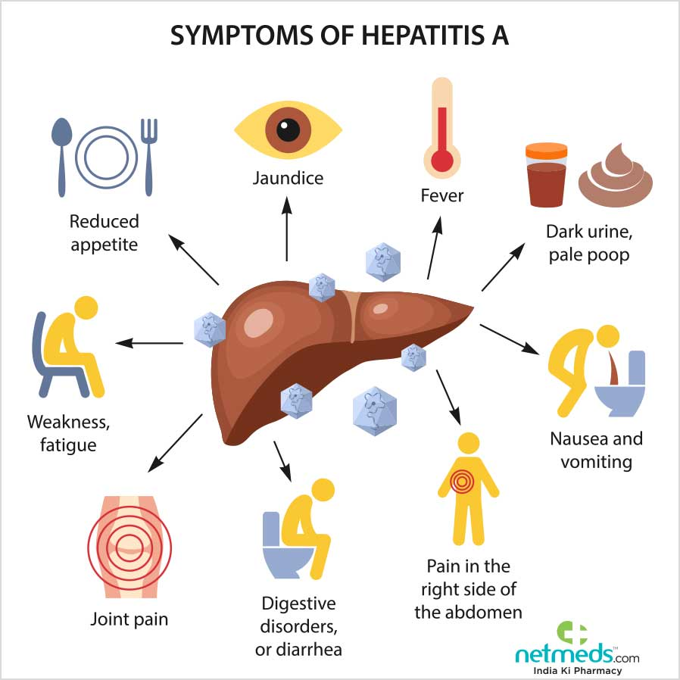

Conclusion
In conclusion, the hepatitis A virus poses a serious health concern in areas where people live. Contaminated sewage materials need to get gathered and disposed of properly to ensure increased sanitation levels. Hygiene needs to get improved to allow for the reduction of transmission of hepatitis A virus amongst people. The creation of productive immunization and vaccination efforts has led to an enhanced state of hepatitis A prevention. People have an opportunity of eliminating the transmission of HAV in their lives after getting vaccinated. Children can get immunized in the process of contacting the disease from the environment. Robust immunization efforts perform appropriate procedures in achieving a high number of people free from the hepatitis A virus.

References
1. Alavi, A., French, L., Davis, M., Brassard, A., & Kirsner, R. 2017. Pyoderma Gangrenosum: An Update on Pathophysiology, Diagnosis and Treatment. American Journal of Clinical Dermatology. Accessed 17 July 2020. <https://doi-org.libproxy.eku.edu/10.1007/s40257-017-0251-7>
2. Centres for Disease Control and Prevention. 2019. Hepatitis A. Accessed 17 July 2020. <https://www.cdc.gov/vaccines/pubs/pinkbook/hepa.html>
3. EASL 2017 Clinical Practice Guidelines on the management of hepatitis B virus infection. 2017. Journal of Hepatology. European Association for The Study of The Liver. Accessed 17 July 2020. < https://doi-org.libproxy.eku.edu/10.1016/j.jhep.2017.03.021>
4. Hasosah, M., Althobaiti, K., Ghandourah, H., & Al-Amir, S., 2011. Acute hepatitis a virus (HAV) infection associated with acalculous cholecystitis. Journal of Pediatric Infectious Diseases accessed 11 July 2020. <https://search-ebscohost-com.libproxy.eku.edu/login.aspx?direct=true&AuthType=ip&db=asn&AN=66691999&site=ehost-live&scope=site>
5. Murthy, N., Rodgers, L., Pabst, L., Fiebelkorn, A. P., & Ng, T. 2017. Progress in Childhood Vaccination Data in Immunization Information Systems. MMWR: Morbidity & Mortality Weekly Report. Accessed 17 July 2020. <https://doi-org.libproxy.eku.edu/10.15585/mmwr.mm6643a4>
6. World Health Organization. 2015. Hepatitis A. accessed 15 July 2020. <https://www.who.int/immunization/diseases/hepatitisA/en/>

